NATIONAL UNIVERSITY OF COMPUTER & EMERGING SCIENCE

Computer Network Lab (CL307)

Lab Session 08

Subnetting and the Subnet Mask

To subnet a network is to create logical divisions of the network. Subnetting, therefore, involves dividing the network into smaller portions called subnets. Subnetting applies to IP addresses because this is done by borrowing bits from the host portion of the IP address. In a sense, the IP address then has three components - the network part, the subnet part and, finally, the host part.

We create a subnet by logically grabbing the last bit from the network component of the address and using it to determine the number of subnets required. In the following example, a Class C address normally has 24 bits for the network address and eight for the host, but we are going to borrow the left-most bit of the host address and declare it as identifying the subnet.
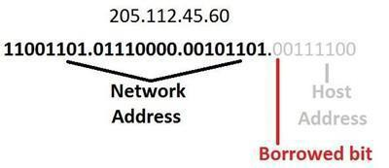

If the bit is a 0, then that will be one subnet; if the bit is a 1 that would be the second subnet. Of course, with only one borrowed bit we can only have two possible subnets. By the same token, that also reduces the number of hosts we can have on the network to 127 (but actually 125 useable addresses given all zeros and all ones are not recommended addresses), down from 255.

So how can you tell how many bits should be borrowed, or, in other words, how many subnets we want to have on our network?

The answer is with a subnet mask.
Subnet masks sound a lot scarier than they really are. All that a subnet mask does is indicate how many bits are being “borrowed” from the host component of an IP address.

If you can’t remember anything about subnetting, remember this concept. It is the foundation of all subnetting.

The reason a subnet mask has this name is that it literally masks out the host bits being borrowed from the host address portion of the IP address.

In the following diagram, there is a subnet mask for a Class C address. The subnet mask is 255.255.255.128 which, when translated into bits, indicates which bits of the host part of the address will be used to determine the subnet number.
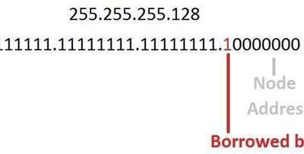

Of course, more bits borrowed means fewer individually addressable hosts that can be on the network. Sometimes, all the combinations and permutations can be confusing, so here are some tables of subnet possibilities.

CLASS C HOST/Subnet Table
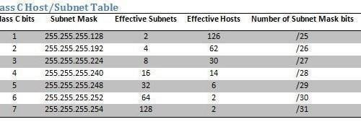
CLASS B and CLASS A HOST/Subnet Table
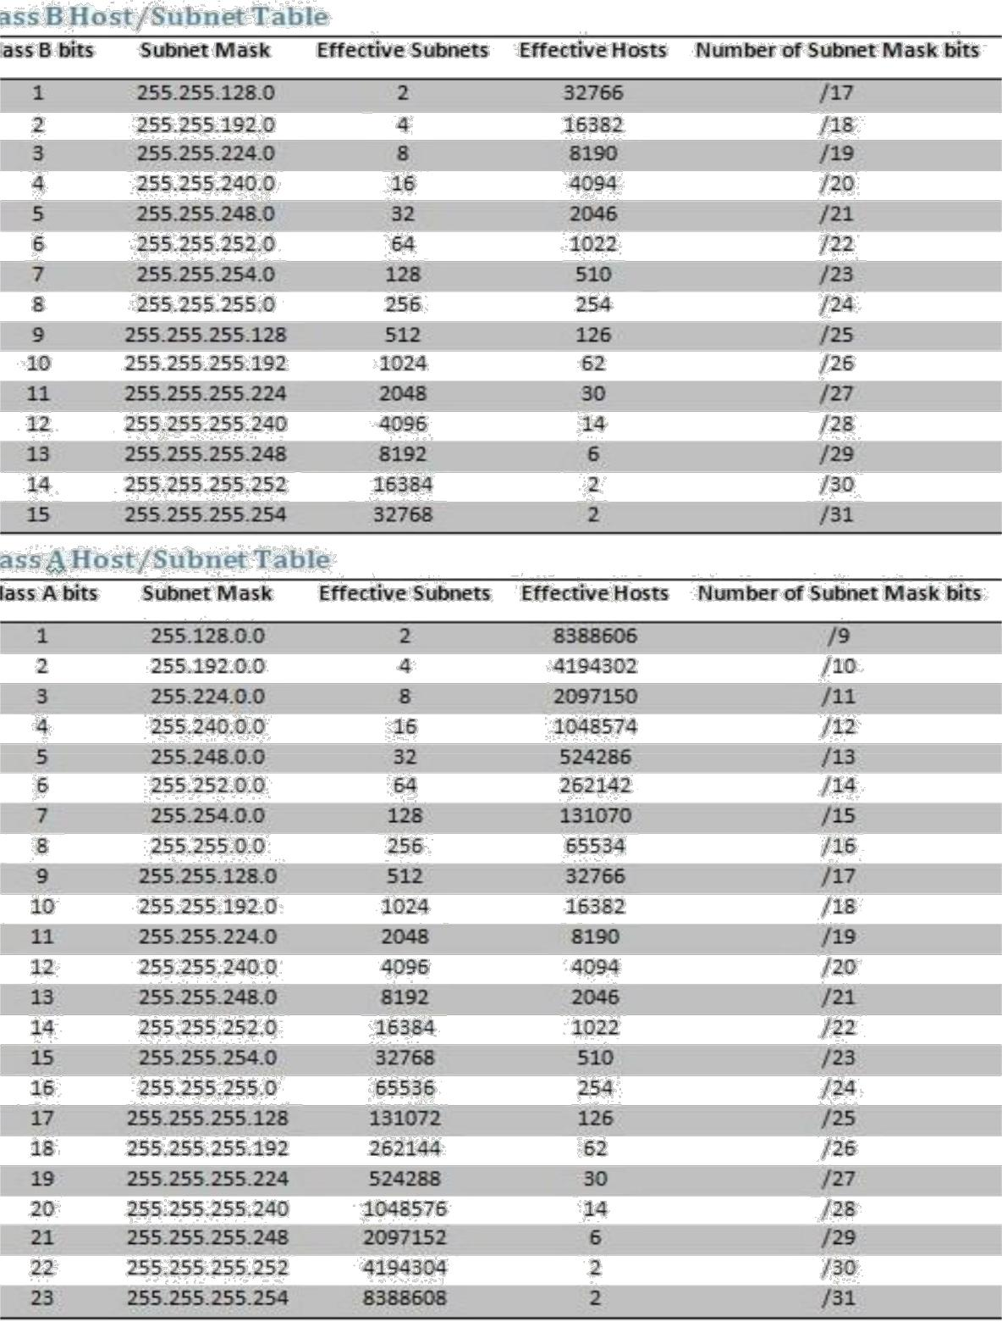
Note that this combination of IP addresses and subnet masks in the charts are written as two separate values, such as Network Address = 205.112.45.60, Mask = 255.255.255.128, or as an IP address with the number of bits indicated as being used for the mask, like 205.112.45.60/25.

Subnet masks work because of the magic of Boolean logic. To best understand how a subnet mask actually does its thing, you must remember that a subnet mask is only relevant when getting to a subnet. In other words, determining what subnet an IP address lives on is the only reason for a subnet mask. It’s devices like routers and switches that make use of subnet masks.

Implementation of Subnetting in Cisco Packet Tracer

Consider an IP of Class C 192.168.1.0/27, using above IP calculate the subnets and implement the scenario in Cisco Packet Tracer.
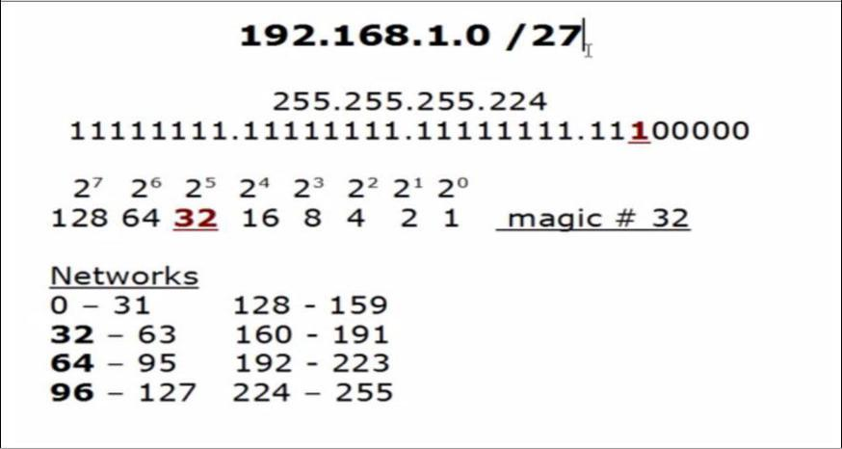

Calculation:

From above, we have:

Possible Subnets:2n = 23 =8

Possible Hosts = 32

Usable Hosts in each Subnet = 32 - 2 = 30

Note: 1st address of every subnet shows network address and last address shows Broadcast address. e.g. 0,32,64 & 96 represent Network address where 31,63,95 &127 represent Broadcast address.

Custom Subnet Mask = 255.255.255.224

Now implementing below scenario in Cisco packet Tracer.
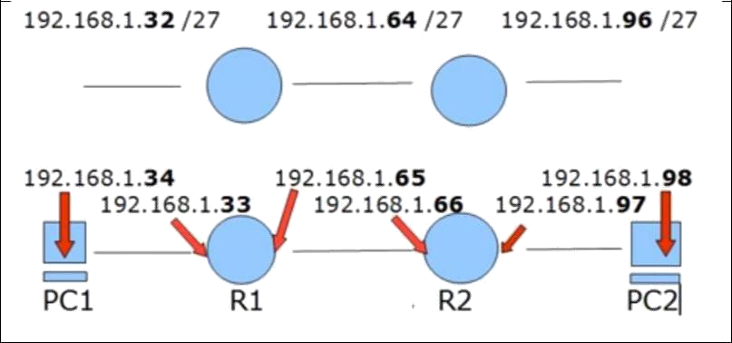

We have taken two routers R1 & R2 and connected their Fast Ethernet interface Fa 0/0 with the switch. While routers connected with their serial interface 2/0.
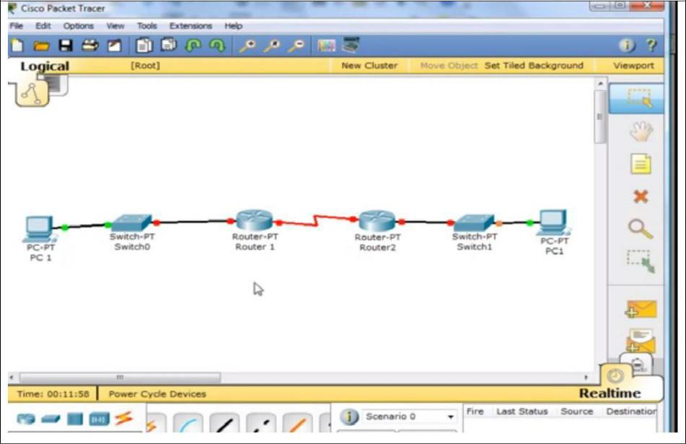
Now configuring PC1.
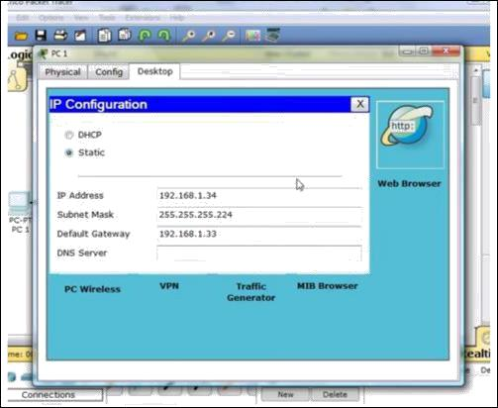

Now configure the Interface FastEthernet0/0 of Router R1.
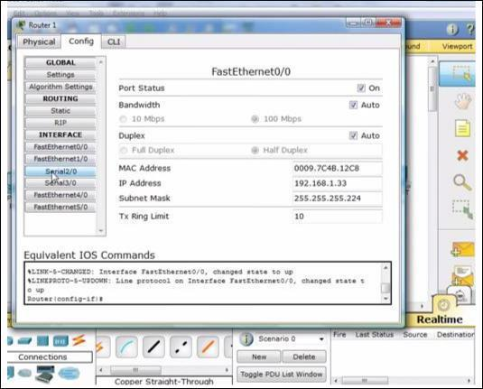

Now configure the Interface Serial2/0 of Router R1.
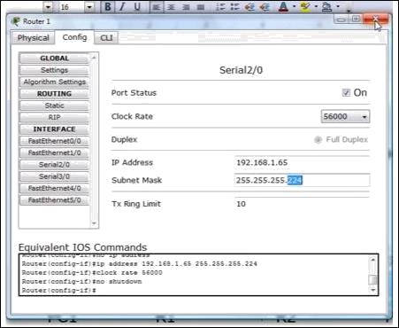

After the configuring the Interface FastEthernet0/0 and Serial2/0 of Router R1.
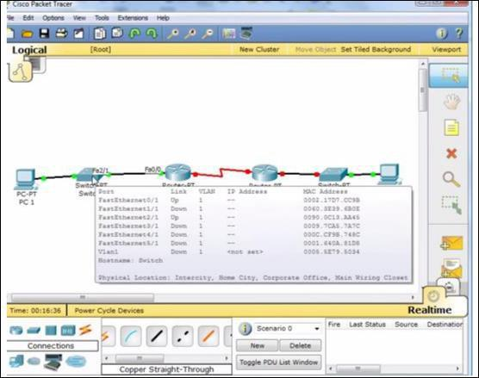
Now configure the Interface FastEthernet0/0 of Router R
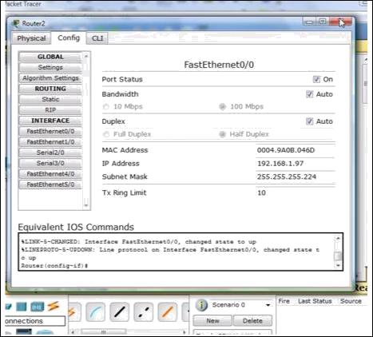

Configure the Interface Serial2/0 of Router R2.
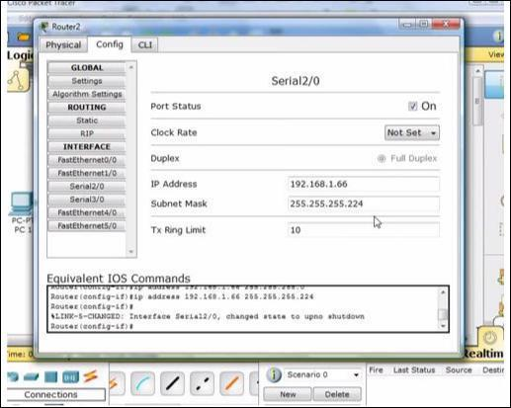
Now configuring PC2.
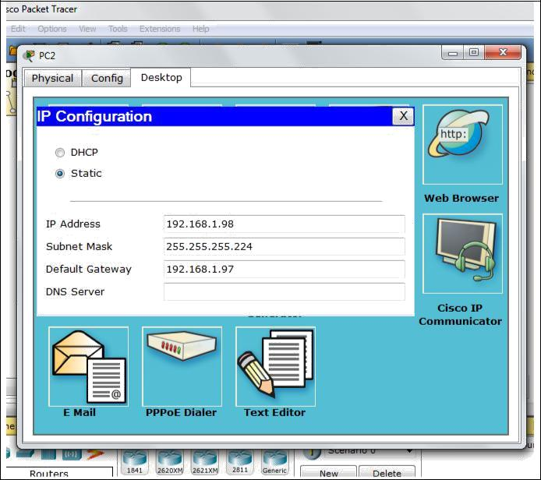

Now we have gone through the entire configuration, all the interfaces are up.
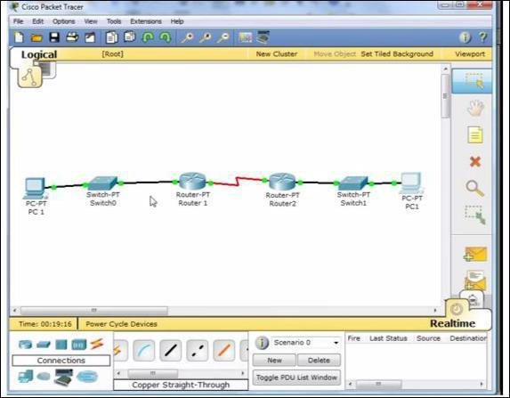

Now let start the pinging the interfaces from PC1.As we ping 192.168.1.33 and
192.168.1.65 we got the reply because these interface are directly connected to Router
R1.
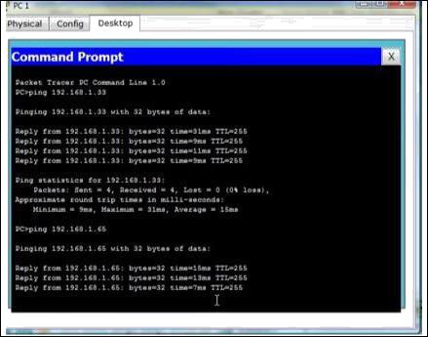

Now we ping 192.168.1.66 we got the Timed out because these interface are not directly connected to Router R1.
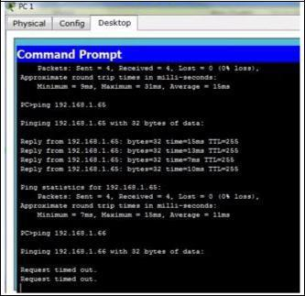

Therefore, we have to add static route in Router R2.
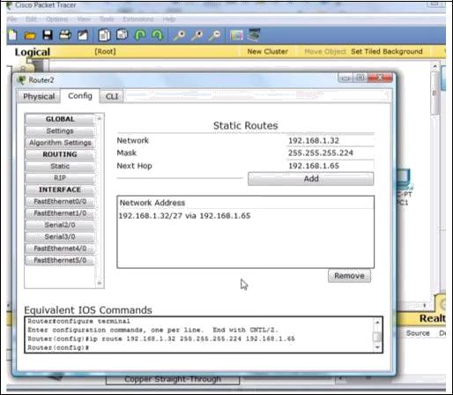

As you can see that we got the reply after adding the static route in Router R2.
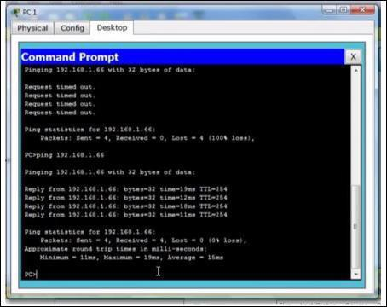
Now using show ip route command we can see all the details of routing table saved in R2.
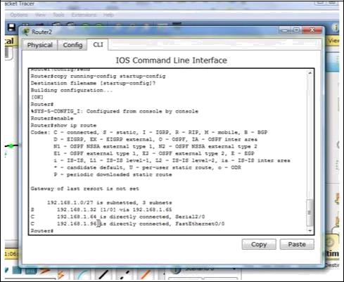

Now similarly add route in Router R1.
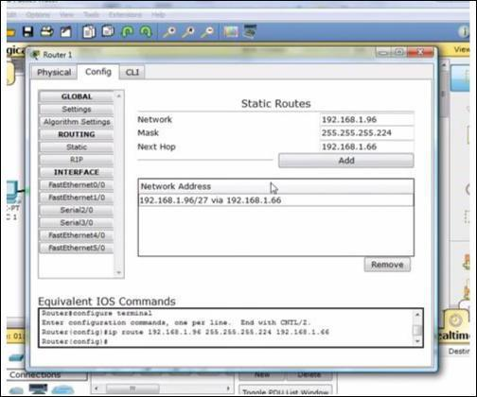
Now we can ping Router R1 from PC.

